Polly Savage

Avenida Mao Tse Tung (or how artists navigated the Mozambican Revolution)
Art, Global Maoism and the Chinese Cultural Revolution Edited by Jacopo Galimberti, Noemi de Haro-García and Victoria H. F. Scott. Manchester University Press. Forthcoming 2020

In February 1972, a group of forty children dramatised Mozambique’s liberation war in song and dance for audiences at the All Africa Fair in Nairobi, Kenya. A project of the Organisation for African Unity (OAU), the Fair hosted representatives from thirty-six independent African states, but also from the OAU-supported liberation movements engaged in fighting white minority rule in South Africa and Namibia, and Portuguese rule in Angola, Guinea Bissau and Mozambique. Orphaned by the latter war, the children were pupils from a primary school for refugees, established in Tunduru, southern Tanzania by the Front for the Liberation of Mozambique, or FRELIMO. Under the direction of FRELIMO minister and poet Sérgio Vieira, they performed in the main arena to assembled dignitaries including Kenyan president Jomo Kenyatta, Ugandan president Idi Amin and Ethiopian Emperor Haile Selassie. In their English language periodical Mozambique Revolution, FRELIMO later described the children’s performance as a “spectacle of Mozambican song and dance”. Four months later, however, the Front’s graphic designer João Craveirinha Jr described it as a “folkloric dance in the genre of communist China”. What interests me here is not so much the performance itself, of which no other record survives, but that the image FRELIMO projected to the world at this point might be remembered in such radically different terms, as paradigmatically Mozambican in official accounts, and paradigmatically Chinese in informal accounts.

FRELIMO garnered broad international support for their struggle for independence, receiving personnel and material and military aid from across the socialist world, as well as Western Europe and the US. They had received substantial backing from China from as early as 1963, and in September 1964, the first shot of the armed struggle came from a Chinese weapon. However, while they had publicly turned to Marxism-Leninism in 1970, there were various reasons why FRELIMO would not openly acknowledge the influence of Maoist thought on their early cultural policy. First, deftly negotiating support from across the ideological landscape, the Front were treading a careful path of neutrality through the Sino-Soviet split (as well as, initially, the Cold War). Second, given this reliance on international support, they were particularly sensitive to charges of neo-colonialism, and from their foundation in 1962 had strenuously sought to defend the autonomy of their policies from imported ideology.

Conversely, there were also significant factors informing Craveirinha’s assessment of the event as Maoist, particularly his split from the Front, and his subsequent return to Portuguese-controlled Lourenço Marques (later Maputo). In laying bare FRELIMO’s cultural debt to communist China, Craveirinha articulates what was unsayable within FRELIMO, but also delivers a barbed attack, betraying his deep disaffection with the Front’s cultural policy.

This chapter draws on interviews and archival records to explore the contradictions of FRELIMO’s relationship to Maoism. It traces the tangible connections between China and Mozambique, and considers the theoretical parallels between FRELIMO’s early discourse on art and that of Mao Zedong in order to shed new light on how the Front’s designation of a national ‘Mozambican’ art and culture actively drew from diverse ideological and aesthetic networks. Arguing that between 1970 and 1977, FRELIMO’s cultural policy borrowed substantially, but not exclusively, from Mao’s, I go on to consider how visual artists experienced these parameters, through a focus on Craveirinha’s practice.

China and FRELIMO
Following the 1955 Bandung conference, China had become keen to develop ties in Africa, largely in competition with both the US, and the USSR after the Sino-Soviet split. Zhou Enlai had visited ten African countries in 1963-4, promising economic, technical and military support to African countries and liberation movements, and returning in June 1965 to visit Nyerere in Tanzania. In 1963, FRELIMO’s deputy, Marcelino dos Santos, and leader Eduardo Mondlane, visited China and met with Chairman Mao Zedong to discuss “the situation in our country, our difficulties and our needs in the revolutionary struggle”. On his return, Mondlane wrote that the visit had convinced him “that the historical struggle of the Chinese people had relevance to the present struggle of the people of Africa”. Despite FRELIMO’s continuing relations with the USSR, Mao responded with an offer of military aid, which was administered through the OAU (to ease the concerns of FRELIMO’s other allies). Shortly afterwards, FRELIMO adopted Mao’s strategy of guerilla warfare, drawing also on the notion of “People’s War” proposed by Vietnamese General Vo Nguyen Giap. Chinese support for this endeavor included scholarships at the Nanjing Military Academy, and the dispatch of personnel, such as the Chinese military instructors stationed at FRELIMO’s training camp in Nachingwea, Southern Tanzania, where Craveirinha studied cartography and reconnaissance from 1967 to 1969. “They showed us a lot of films, documentaries shot on location, of the Chinese intervention in Korea, the war against the Japanese”, he remembered, “they would try to indoctrinate us against the Soviet Union”. However, he recalls that these attempts to promote Maoism were often met with resistance in the liberation camps:
We had theoretical classes [and] we had to sing some words in praise of Mao Zedong. Even now I can sing it: “Dōngfāng hóng, tàiyáng shēng,
Zhōngguó chū liǎo ge Máo Zédōng” They used to give us those red books of Mao Tse Tung about the Cultural Revolution, translated into Portuguese. One day some pages were found in the rubbish. The Chinese instructor and the delegation of Chinese wanted to talk with Samora about this, they said it was disrespectful. Samora Machel called a meeting to announce: “we are not going to accept any gifts of books from Mao Zedong whatsoever. We told our Chinese comrades not to give these books. The majority of our guerrillas don't even know Portuguese anyway.
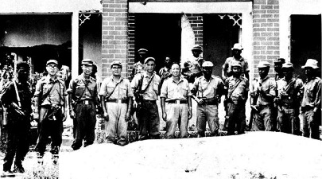
Figure 1 Chinese delegation with Samora Machel and other FRELIMO representatives in recently liberated post Muidame, 1972. Source: A Voz da Revolução 7 Jan-Feb 1972 p4

FRELIMO’s early position on the arts, outlined under Mondlane’s leadership, bore little resemblance to Maoist thought, tending instead towards models of cultural nationalism and African socialism which to a large degree embraced ethnic difference and particularism. Whilst from the beginning the party sought to mask ethnic divisions and unite Mozambicans into a supra-ethnic nationhood, the initial years saw a series of attempts to assimilate regional traditions and beliefs. This included the development of a Makonde sculptors’ cooperative in a liberated zone of northern Mozambique, the products of which were sold in Mtwara, Tanzania to subsidise the costs of war, or presented as diplomatic gifts to FRELIMO’s allies. Like his host, Tanzanian president Julius Nyerere, Mondlane argued that tradition offered an indigenous resource from which to develop both nationalism on specifically African terms.

These policies married well with João Craveirinha Jr’s visual practice. Nephew of the celebrated poet José Craveirinha, and a descendant of the noble Mphumo lineage, Craveirinha had left a comfortable life in Lourenço Marques to join the Front in 1967. After training for two years as a cartographer with the Chinese instructors in Nachingwea, he was transferred to the Front’s Department of Information and Propaganda (DIP) in Dar es Salaam. By this stage, it had become imperative for FRELIMO to disseminate a visible image of its activities in order to attract aid and support from the international arena, and to this end Craveirinha and his colleagues at the DIP produced radio broadcasts, developed and edited the camera reels that arrived from the liberated zones, and designed layout and illustrations for FRELIMO’s publications.

In 1970, Craveirinha was also charged with designing a new history textbook for the FRELIMO schools. Conceived as a rejoinder to the Portuguese colonial education system, História de Moçambique traced a genealogy for the nation through a history of indigenous resistance to foreign intervention, from the fifteenth century Mutapa Empire, to the early slave trade, the establishment of colonial farms or prazos, and the start of the armed struggle in 1964. Craveirinha’s cover image is bisected by a vertical divide,
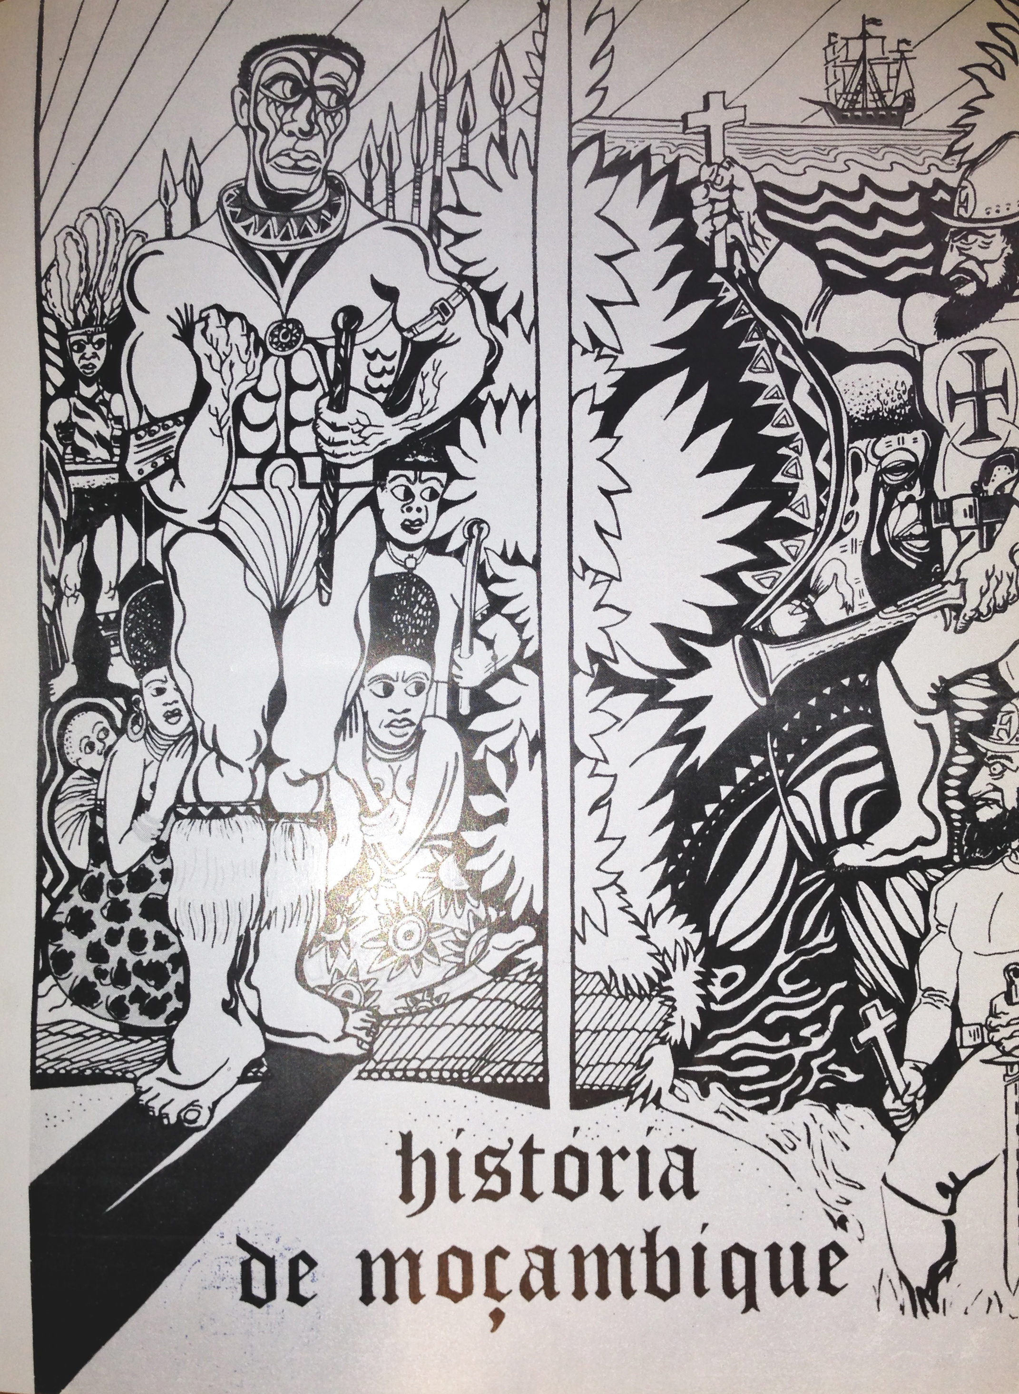
Figure 2 João Craveirinha Jr, Design for História de Moçambique (History of Mozambique) FRELIMO schools textbook, 1970. Reproduced in Mozambique Revolution 48, 1971 [NB Image to be rescanned]
a no man’s land across which Africans and Portuguese glare aggressively. The right panel depicts the arrival, by ship, of two Portuguese agents. They lurch towards the Africans, blunderbuss and sword in one hand, Catholic cross in the other, Portuguese Order of Christ cross blazoned on their armour. The left panel is dominated by the imposing figure of a chief, his powerful fist poised in defiance while women and children shelter behind him, wrapped in capulana fabrics. Like his cover for the 1971 poetry anthology Poesia de Combate, Craveirinha’s drawing gave prominence to the recurrent motif of a muscular patriarch in the regalia of local authority. The force of indigenous resistance takes metonymic form here, in the physical strength of a single, male body, but also through adornments including a beaded collar, amishoba cow tufts at his legs, and a knobkerrie club. Encoding a political iconography, these objects point to Tsonga and Shangaan traditions from the south of the country, while lines across his cheeks and forehead suggest Makonde facial tattooing and scarification from the north of the country. Through these conflated traditions, Craveirinha alludes to the potential for an individual agent to invoke metaphysical forces as a strategy in the anti-colonial struggle.
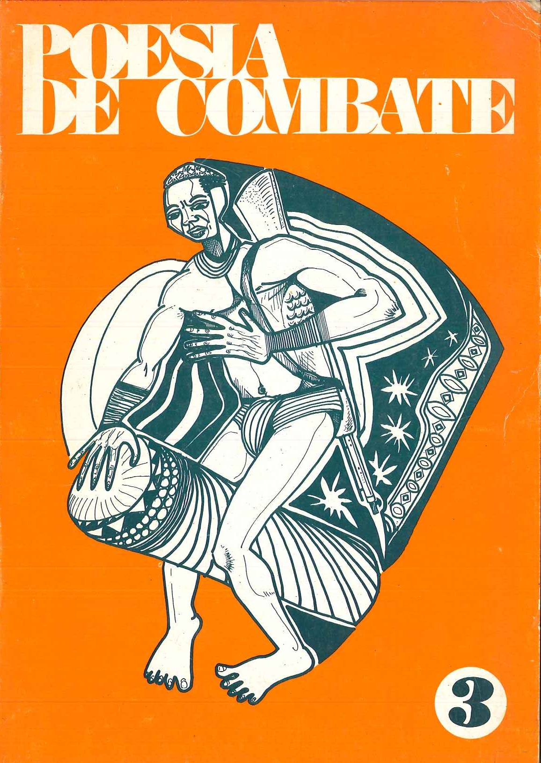
Figure 3 João Craveirinha Jr, Cover design for 1971 FRELIMO anthology Poesia de combate (Poetry of Combat). Pictured: Volume 3, 1979 edition, Maputo

In his 1969 account of the war The Struggle for Mozambique, Eduardo Mondlane pays tribute to Craveirinha’s evocations of local authority, suggesting that he and the painter Malangatana “draw their inspiration from the images of traditional sculpture and from African mythology, binding them into works explosive with themes of liberation and the denunciation of cultural violence”. However a policy shift would soon lead to very different aesthetic parameters for FRELIMO’s vision of the Mozambican nation.

FRELIMO’s Maoist shift
By the late 1960s, FRELIMO was divided on ideological lines between African nationalists (including Lazaro Nkavandame and Uria Simango), and younger, more hardline Marxists (including Samora Machel, Jorge Rebelo, Sérgio Vieira and Marcelino dos Santos). The early months of 1969 saw several senior figures purged from the Front, and the assassination, by letter bomb, of Eduardo Mondlane. By May 1970, the Central Committee had confirmed Samora Machel as President, and Marcelino dos Santos as Vice President. Under this new leadership the Front drew from a range of sources, including Mao Zedong thought, to develop a re-reading of Marxism-Leninism that was uniquely adapted for the Mozambican context. A number of factors led to this shift.

There were significant parallels in the historical experiences and social structure of Mozambique and China. The industrialised working class in Mozambique, at the time of independence, was a tiny minority compared to the peasantry, a configuration that left little hope for imminent socialist revolution in an orthodox Marxist sense. In contrast to Leninism, Maoism provided a solution to this dilemma, by framing the peasantry not as landowners but as historically oppressed masses who could be mobilised for revolution. Michael Radu records that Samora Machel had become “enamoured” by Mao’s Little Red Book during his training in Algeria. Machel went on to visit Beijing in 1968, 1971 and 1975, and concluded that “China is a country once subjected to imperialist rule and bullying. Like the Chinese people, the people of Mozambique are compelled to take the road of protracted struggle”. The attraction of Mao, he argued in 1974 , was the Chinese leader’s capacity to adapt socialist policy for new contexts: “Mao developed Marxism-Leninism in a creative way and that is the fundamental thing: how to apply Marxism given specific conditions? That is the only way to avoid making Marxism into a dogma”. China also offered a radical model for modernisation that visibly departed from both colonial alliances and the European associations of Soviet Marxism-Leninism, as well as a practical plan for consolidating centralised authority as a revolutionary party.

FRELIMO’s move towards this strand of Marxism-Leninism can also be seen as a pragmatic choice, necessitated by the contingencies of securing international aid. Following the Cultural Revolution, the PRC had begun to insist that any liberation movement receiving aid from China must explicitly approve of Maoism as a guiding principle. Speaking to Tor Sellström in 1996, Jorge Rebelo affirmed this more pragmatic factor in FRELIMO’s policy decisions:
We wanted as much support as possible, wherever it came from… [China and the USSR] had their geo-strategic interests. There were certain moments—in fact many moments—when their support was given under very strict conditions. The basic condition was to support their policies and condemn—now that expression no longer exists—imperialism... we could not say as much as I am telling now. We depended absolutely on their support for the war effort.

The shift towards Maoism can also be understood as a response to the multiple discursive and affective transnational networks converging on the Front during this time. FRELIMO’s policies were formulated in Tanzania at a time when Nyerere was also developing close relations with China, an alliance which supported the funding of the Tazara railway link between Dar es Salaam and the Zambian Copperbelt, and which was reflected in Nyerere’s a penchant for Mao-style suits. Priya Lal has documented other diffusions of Maoist cultural expression in Tanzania during this time, including film screenings organised by the Chinese embassy in Dar es Salaam, dance and theatre events (including a public production of The East is Red performed by Chinese cultural troupes, attended by TANU leaders) and the distribution of badges featuring Mao’s portrait in secondary schools.

The inflections of FRELIMO’s policy on culture can also be traced through much broader global connections. An early hub for anti-colonial networks had been the Casa dos Estudantes do Império (CEI, House of the Students of the Empire) in Lisbon. Marcelino dos Santos, Jorge Rebelo and Sérgio Vieira had all studied in Lisbon, and met with Amílcar Cabral, Mário Pinto de Andrade, Agostinho Neto and other nationalist leaders through the CEI. Under pressure from PIDE, dos Santos and de Andrade relocated to Paris in 1950, where they became involved with Alioune Diop’s literary journal Présence Africaine, and in 1957 helped to form the Anti-Colonial Movement (MAC). By the time dos Santos left Paris in the early 1960s, the radical left in France were increasingly looking to Mao’s China for inspiration, a commitment explored in Jean-Luc Godard’s 1967 film La Chinoise and by Kristin Ross, who has argued that from the early 1960s, the French “third-worldists” saw in the liberation struggles in Cuba, Africa and Vietnam, the possibility for the “merging of the themes of anti-imperialism and anti-capitalism, the theoretical justification was loosely provided by Maoism”. Dos Santos travelled extensively during this time, not only in Western Europe, but to also to address conferences in Tashkent, Tunis, Addis Ababa, Moscow, Havana and elsewhere. His participation in these networks opens the possibility for understanding FRELIMO’s cultural policy not only as a pragmatic policy, or an indigenous philosophy, but also as a resonance of more complex transnational networks which superseded Cold War polarities. Through these networks, a circulation of people, arms, education, print media, objects, images and capital generated a vast, shifting geography of ideas and affect, which bound FRELIMO’s struggle into globally expansive relations.

FRELIMO’s visual culture policy
What then were the implications of these networks for FRELIMO’s cultural policy, and its artists? At FRELIMO’s Second Party Congress in July 1968, the Front had defined its aim to: “destroy Portuguese colonialism in all its forms, political, economic, social and cultural.” Two years later, at the second conference of the Department of Education and Culture in September 1970, Samora Machel expanded the aims of the struggle to include a self-critique of Mozambican society in a direct, unacknowledged citation of Mao’s method of self-criticism. In this new configuration, FRELIMO waged war not only against an external enemy, but also against what he would later call “the enemy within”, understood as “subjectivism, individualism, tribalism, arrogance, superstition [and] ignorance” in the Mozambican population. This war sought a radical re-invention of the citizen, at a psychic level, into the figure of the homem novo, or the ‘New Man’. The term threads through the globally networked discourse in which FRELIMO increasingly participated from 1970, (for Mao Zedong, a process of ‘ideological remoulding’ would produce ‘new men with new minds, new ideas, new emotions, and new attitudes’ for example). The idea was later consolidated as a central tenet of the Party’s post-independence directives by Sérgio Vieira.

In July 1971, at a UNESCO-run seminar in Dar es Salaam entitled “The Influence of Colonialism on the Artist, his Milieu and his Public in Developing Countries”, Armando Guebuza and Sérgio Vieira outlined their vision for a “new culture”, in line with Machel’s new policies. Their paper defined four parameters for the visual arts which would be foundational to cultural policy over the next decade, and against which João Craveirinha Jr would soon come into conflict. These parameters proposed new definitions for, respectively: national identity; the artist and their audience; the social role of art itself; and finally, the art object as commodity. The first of these was the production of a national culture that superseded ethnicity in its media and distribution.

Where necessary, FRELIMO had formed strategic alliances with the curandeiros (healers) and régulos (local hereditary chiefs) in the liberated zones, but the Marxist faction within the Front had been fundamentally opposed to their authority. The party would go on to launch a full-scale attack on local healers and belief systems, which were targeted as “obscurantist”, anti-progressive and divisive. Metaphysical beliefs and practices were denounced as “false consciousness” and régulos were systematically supplanted by party representatives in a struggle for control over the population of the northern liberated zones. “To unite Mozambicans”, argued Machel, “transcending traditions and different languages, requires that the tribe must die in our consciousness so that the nation may be born”. Guebuza and Vieira expand on this approach, arguing that:
We are building a new culture, a national culture which is negating and transcending both the tribal micro-cultures and the colonial anti-culture, a culture which is assuming the geographical and historical dimensions of the whole people, a culture which is making the masses in a given region assume the values of another region as their own.
They refer here to a FRELIMO initiative that compelled troops in the liberated zones to perform and teach each other dances and songs from different parts of the country, and the dispatch of Makonde carvers to teach at Tunduru school. By dislocating traditions from their original context, it was hoped that they could be repurposed in pursuit of national unity.

This factor helps to explain the absence of visual markers of ethnicity in official arts over the following decade. Alexander Bortolot has observed the erasure of ethnic markers such as lip plugs, facial tattoos from Makonde sculptures in the mid-1970s. Similarly, João Craveirinha Jr found his work was frequently edited to remove elements such as body adornments, curandeiros’ implements and local authority figures. His cover design for the História de Moçambique textbook was reproduced, after independence for example, on a poster entitled Invasão, Opressão, Resistência.

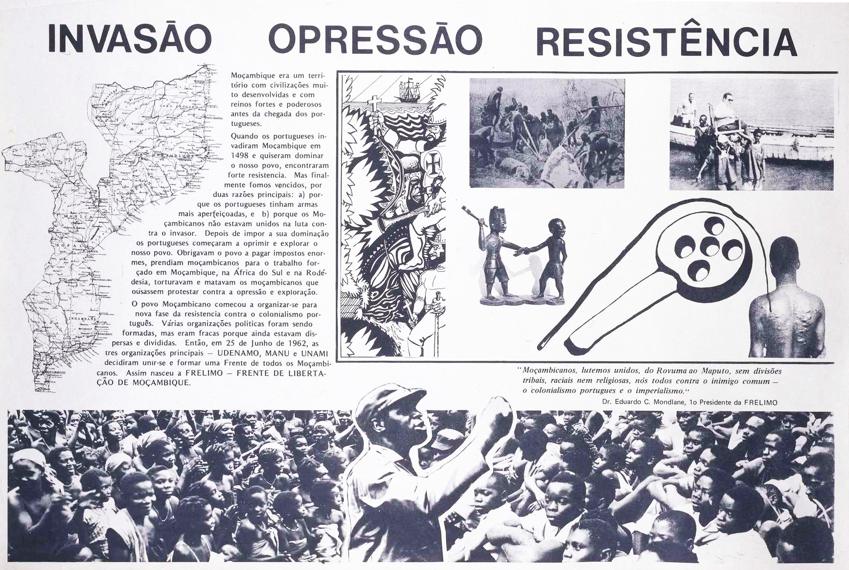
Figure 4 DNPP Invasão Opressão Resistência (Invasion Oppression Resistance) Poster featuring detail of 1970 drawing by João Craveirinha Jr. c1976, Maputo. Source: Fundação Mario Soares

Part of a series of three posters produced by the National Directorate of Press and Propaganda to inform the public of Frelimo’s primacy in the liberation struggle, the layout combines, at the left, a tract of text about the struggle, wrapped around a map of the country, and at the right, images of colonial excess, including a graphic depiction of the welts caused by a palmatória paddle. Craveirinha’s drawing is at the centre of the poster, but in radically edited form: only the right panel, featuring the Portuguese, is included. Whilst the “enemy” remains unchanged, the image of “popular resistance” is transformed. In place of Craveirinha’s rural family and forest of spears, a photographic collage at the base of the poster shows a seated crowd, a visual synecdoche for O Povo, or The People, their focus fixed on a central point. In both images, a central hero figure leads the resistance, fist raised, but on the poster, in place of Craveirinha’s spiritual leader, is the martyred Eduardo Mondlane, in battle fatigues, mid oratory. This process of editing lends visual form to FRELIMO’s reconfiguration of the people, their history and their heroes, and evokes the historic tension between Mao’s eulogy of the agency of the “masses”, and the veneration he enjoyed.

The second imperative outlined by Vieira and Guebuza concerned the role of the artist. The conception of the visual artist as a uniquely individual agent, self-motivated and autonomous from political context, was the antithesis of FRELIMO’s vision for the New Man. Assimilating the visual artist into the new social order and collective consciousness therefore demanded the dissolution of individual authorship. Within the new, revolutionary society, they argued:
Our theatre, our music, our songs, our sculpture, our painting, our literature, are all forged with the active participation of the masses, without the distortion created by the contradiction between the public as object and the creator as subject.

The success of the artist, they argued, would depend on integration with “revolutionary values” which were “universal at the same time as being national”, and which would bind the nation’s artists into global relations “because it is a part of the struggle of all of mankind for social and cultural liberation”. Primarily though, the path to this sublimation was through allegiance to the party: “This possibility of solving the contradiction between an object public and a creative public starts with the artist joining the political formation which is leading the people to transform society”. A visible strategy for bringing about artists’ integration with the masses, and the party, was a directive which barred artists and authors from signing their work. Visual material produced within FRELIMO between 1970 and 1982 is almost exclusively unattributed; João Craveirinha Jr’s design for the cover of Poesia de Combate is signed “FRELIMO”, for example, as were many of the poems inside. FRELIMO also prevented the attribution of authorship in the photographs which they processed and published. Jorge Rebelo explained this policy to Drew Thompson as a recognition of the primacy of the Party in processes of image production:
Saying I, Rebelo, did this would weaken the liberation movement. A photograph, okay it was taken by a photographer but how did he manage to produce this? It was thanks to the liberation struggle, because if there was no struggle he would not be able to.

This policy met with some intransigence from several visual artists in Mozambique, including João Craveirinha Jr, who continued to sign many of his drawings with pseudonyms including “Mpfumo Craveirinha” (from 1964), “Mangashane Mpfumo” (from 1970), and “Kraveirinya” (from 1972). The third imperative outlined by Vieira and Guebuza in their 1970 speech took this call further, by proposing that not only the artist, but the concept of art itself, should be reinvented for a revolutionary context:
Our art grows with the maize we are cultivating in the cooperatives, with the adults and children to whom we are teaching literacy, with the enemy bases we are destroying. Because our art is revolutionary, it both dies and is born in praxis.

The final imperative outlined by Vieira and Guebuza at the Dar es Salaam seminar was that artists should disavow themselves of bourgeois art institutions, by relocating their work into new social and economic structures:
As artists our place is not in libraries and museums […] our role is not to be in the middle of the public square on monuments; we should be there only when the people have created freedom there… We are not working for a gadget culture, a luxury culture; our art, our culture, emerges from our involvement in day-to-day life.
This imperative concerned the location in which art was consumed, but also the status of the art-object within the new economy. Objects such as Makonde sculptures continued to circulate as commodities within Tanzania’s market, and FRELIMO, in the role of a proto-state, assumed control of this trade in order to generate profit for the struggle. In 1970, the Tanzanian government had taken further steps in this direction by forming the National Arts of Tanzania (NAT, an offshoot of the National Development Corporation), and nationalising the art market. Galleries and art-dealerships were reassigned to the state, and Ismaili Zanzibari dealer Mohamed Peera was appointed first manager of NAT. In May 1972, Craveirinha was discovered to have been selling small drawings in china ink through Peera’s shop, and was charged by FRELIMO with “fomenting discord in information; not obeying party rules of political comportment; lacking respect for ‘Comrade President’; selling his drawings without authorisation and using the name of the revolution to accumulate funds”. Having been told he would be sent back to Nachingwea, Craveirinha slipped out of the FRELIMO offices early one morning and boarded a bus to Kenya, travelling from there back to Lourenço Marques, were he was detained by the Portuguese secret police, PIDE.

In their approach to culture, FRELIMO drew selectively from broad networks of discourse to construct a policy that was grounded primarily in the Mozambican experience. Nevertheless in important respects these four parameters for a new Mozambican culture bear close comparison with Mao Zedong’s approach, including his insistence at the Yenan Forum in 1942, that artists and writers “must change and remould their thinking and their feelings” such that they be “fused with those of the masses of workers, peasants and soldiers”. Like FRELIMO, Mao sought a new, revolutionary culture that spurned the dead weight of tradition and focused on the destruction of old customs, cultures, habits and ideas. For artists such as Craveirinha, who were deeply invested in such traditions, these policies had a profound impact not only on their practice, but on the trajectory of their lives.

Following Portugal’s 1974 Carnation Revolution and the formal initiation of the decolonisation process in Mozambique, João Craveirinha Jr
surrendered to the FRELIMO headquarters in Dar es Salaam. Following an extended detention in a basement in the city, he was transferred to Nachingwea. Here, on 16 March 1975, he stood trial as one of a group of 240 Mozambicans accused of treason against FRELIMO during the liberation struggle. Also on trial was Lazaro Nkavandame and former FRELIMO vice-president Reverend Uria Simango. These detainees subsequently disappeared, and are thought to have been secretly executed at some point between 1977 and 1983, but João Craveirinha Jr was sent from here to a re-education camp in Niassa. He describes a hostile environment, in which detainees shared a water resource with wild animals, and faced lethal attacks from lions and snakes. He remained there until April 1976, when Samora Machel issued him a pardon and allocated him work as a graphic designer for the National Directorate of Press and Propaganda. He went on to produce many of Mozambique’s most iconic political posters and headed the production of the epic 105-metre mural in Maputo’s Praça dos Heróis Moçambicanos in 1979, before leaving for Portugal in 1983.
Figure 5 João Craveirinha Jr. 1o Maio, Dia do Trabalhador (1st May, Day of the Worker) Four-colour offset lithography poster, DNPP c1979. Source: Centro de Documentação e Formação Fotográfica, Maputo

Conclusion
João Craveirinha Jr’s account of his fraught relationship with FRELIMO is instructive on a number of levels. On a national level, his deep disaffection with the front’s cultural policy offers an embittered counter-narrative to official accounts of the Mozambican Revolution. On a transnational level, his intransigence brings into relief some of the less recognised reverberations of Maoist cultural policy in Africa during the early 1970s. On an even broader level, his particular trajectory also brings insight into some of the tensions and contradictions generated at the interface of geo-political strategy, artistic agency and lived experience.

In 1985, visual artists in Maputo staged a protest demanding remuneration for the state’s appropriation of their work, and in 1987, Frelimo released a briefing entitled “The Weapon of Culture” which outlined a retreat from earlier cultural policy, highlighting “the lessons that can be drawn from Mozambique’s early experiments and experience”. The briefing concluded that “the state must offer effective support without unwittingly stifling initiative… [to avoid] the danger of sterility in official art”. Following a full-scale swing to neoliberalism in the mid-1980s, Frelimo has actively sought to erase its dalliance with Maoism. Still running through the centre of Maputo, however, is Mao Tse Tung Avenue, stubbornly anachronistic, a monument to the aesthetic and political networks the party would prefer to forget.

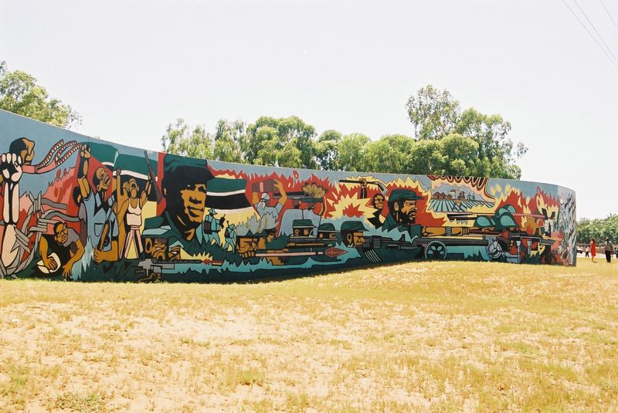
Figure 6 João 'Mphumo' Craveirinha Jr (head designer and production), José Freire (editor) and collective (production) Mural at Praça dos Heróis Moçambicanos, Bairro de Aeroporto, Maputo 1979 (renovated 2000) Paint, 5mx105m.

Under the umbrella of the African Liberation Committee, founded in 1963, the OAU offered financial and diplomatic support to liberation movements including FRELIMO in Mozambique, the MPLA and the FNLA in Angola, the PAIGC in Guinea Bissau, the ANC and PAC in South Africa, ZAPU and ZANU in Rhodesia and SWAPO in Namibia.
The delegation to the fair included Joaquim Chissano, Sérgio Vieira, Oscar Monteiro, João Nankuta (as a technician), Eduardo Mondlane Junior, and the Tunduru school children. For the Liberation Committee pavilion, they construct a reed thatch house, which housed a display of photographs, sculptures and produce from the communal villages of the liberated zones of Northern Mozambique. FRELIMO, “A FRELIMO Na 1a Feira Panafricana,” Mozambique Revolution, March 1972, 3.
FRELIMO, 3.
Dirrecção-Geral de Segurança, “Apresentação,” July 15, 1972, Direcção-Geral de Arquivos, Arquivo Nacional da Torre do Tombo.
FRELIMO’s first leader, Eduardo Mondlane, managed to draw material and logistical support for the Front from across the ideological landscape. Although Portugal’s membership of NATO prevented the US from offering overt support to FRELIMO, Mondlane built on his US connections to secure aid for education projects in Tanzania. In 1962, his American wife Janet Mondlane successfully applied to the Ford Foundation in New York for a grant to build a boarding house in Dar es Salaam for 52 young Mozambican refugees to attend local secondary schools. Two years later, Mondlane met with Robert Kennedy and secured a $96,000 grant from the Ford Foundation to establish a school for the Mozambican refugees near Dar es Salaam, the Mozambique Institute (MI), which was staffed by teachers from Sweden, India, the US, the UK, Czechoslovakia, East Germany and Mozambique. Throughout the struggle FRELIMO continued to receive bi-lateral aid and donations from government agencies and solidarity groups in China, the USSR, Cuba, Finland, Sweden, Poland, East Germany, Britain, Italy, Portugal, the Netherlands, Yugoslavia, Czechoslovakia, Romania and elsewhere.
“Mozambican Leaders Visiting China,” Mozambique Revolution, January 1964, 9, Archive of the Bishopsgate Institute, London.
cf Thomas H. Henriksen, “Marxism and Mozambique,” African Affairs 77, no. 309 (October 1978): 443.
Vo Nguyen Giap, People’s War People’s Army: The Viet Cong Insurrection Manual for Underdeveloped Countries (Hanoi: Foreign Languages Publishing House, 1961). With some adaptations, the 1945-8 campaigns of the China’s People’s Liberation Army in Manchuria provided a template for strategy in the liberated zones. The guerilla approach was preferred over other models such as insurrection in the capital, which had failed in Luanda in 1958 and in Guinea Bissau in 1959.
João Craveirinha, Telephone interview with author, March 10, 2016; In his autobiography, Sérgio Vieira recalls that the Chinese instructors at Nachingwea “refused to train us with Soviet weapons, insisting on using Chinese copies which were rarely as good as the originals. They alleged that we could not trust them, and that they might be booby-traps!” He describes the Chinese contingent as “modest, diligent, extremely competent”, recalling that they celebrated Chinese festivals together “with a beer and the rice spirit Mo Tay”. Sérgio Vieira, Participei, Por Isso Testemunho (Maputo: Ndjira, 2010), 616.
João Craveirinha, Interview with author, Lisbon, February 19, 2017 “The east is red, the sun is rising. From China comes Mao Zedong”. The East is Red became China’s de facto anthem during the 1960s Cultural Revolution.
Craveirinha.
See Alexander Bortolot, “Artesãos Da Nossa Patria: Makonde Blackwood Sculptors, Cooperatives, and the Art of Socialist Revolution in Postcolonial Mozambique,” in African Art and Agency in the Workshop, ed. Sidney Littlefield Kasfir and Till Förster (Indiana University Press, 2013), 259.
“Information and Propaganda” had been defined as priorities at FRELIMO’s two Congresses, in 1962, and in 1968 when it was argued to be “very important in our Revolution, particularly in the mobilisation of the people for the struggle”. “Resolutions of the Central Committee,” Mozambique Revolution, September 25, 1968, 6, Archive of the Bishopsgate Institute, London; This directive corresponded to Mao’s first stages of guerrilla warfare, which he defined as “[a]rousing and organizing the people [and] achieving internal unification politically” Mao Zedong, On Guerrilla Warfare, trans. Samuel B. Griffith (Courier Corporation, 1937), 43.
Film and photography offered effective media for this purpose, and FRELIMO invited foreign filmmakers, journalists and writers to visit and document the liberated zones, including Yugoslav director Dragutin Popović in 1966 and British director Margaret Dickinson in 1971. FRELIMO encouraged solidarity workers to train its soldiers as photographers and personnel were also sent to Romania to learn photographic techniques. As a result of these campaigns, FRELIMO’s struggle had, by the late 1960s, become the focus of diverse and expansive solidarity networks. See Ros Gray, “Haven’t You Heard of Internationalism? The Socialist Friendships of Mozambican Cinema,” in Postcommunist Film - Russia, Eastern Europe and World Culture: Moving Images of Postcommunism, ed. Lars Lyngsgaard and Fjord Kristensen (Abingdon: Routledge, 2012), 53–74; Kodwo Eshun and Ros Gray, “The Militant Image: A Ciné‐Geography,” Third Text 25, no. 1 (January 1, 2011): 1–12; Drew A. Thompson, “Visualising FRELIMO’s Liberated Zones in Mozambique, 1962–1974,” Social Dynamics 39, no. 1 (March 1, 2013): 24–50; Drew A. Thompson, “Constructing a History of Independent Mozambique, 1974-1982: A Study in Photography,” Kronos 39, no. 1 (January 2013): 158–84; and Berit Sahlström, Political Posters in Ethiopia and Mozambique: Visual Imagery in a Revolutionary Context (Stockholm: Uppsala, 1990), 60. As well as textbooks and poetry anthologies, FRELIMO’s regular publications included the official Portuguese language organ, A Voz da Revolução (1966-1981) and its English language counterpart, Mozambique Revolution (1967-1975). These publications had begun as monochrome, and then bi-chrome, stapled pamphlets, produced in small runs on a manually operated mimeograph machine. In 1970, a student group in Finland coordinated a solidarity campaign (Taksvärkki-69) to donate a Gestetner printing press to the Front, which supported a dramatic increase in the quality and quantity of their publications. The History textbook was the first publication produced on the Gestetner.
Michael A. Samuels, “The FRELIMO School System,” Africa Today 18, no. 3 (July 1971): 70. By late 1966, growing numbers of refugee children in Tunduru led FRELIMO’s Department of Education and Culture to open another school. By 1969 the school had around 350 students enrolled in three primary classes. By 1971, FRELIMO claimed to have built 125 schools in the liberated zones of Niassa, Cabo Delgado and Tete.
Eduardo Mondlane, The Struggle for Mozambique (Harmondsworth: Penguin, 1969), 108.
Michael Radu, The New Insurgencies: Anti-Communist Guerrillas in the Third World (Routledge, 2017).
New China News Agency, August 25, 1971, cf Ian Taylor, China and Africa: Engagement and Compromise (Routledge, 2007), 96.
Samora Machel 1974, cf João Titteringtom Gomes Cravinho, “Modernising Mozambique: Frelimo Ideology and Frelimo State” (University of Oxford, 1995), 131.
Michael Mahoney, “Estado Novo, Homem Novo (New State, New Man): Colonial and Anticolonial Development Ideologies in Mozambique, 1930–1977,” in Staging Growth: Modernization, Development, and the Global Cold War, ed. David C Engerman et al. (University of Massachusetts Press, 2003), 165–198.
Michael Panzer, “Pragmatism and Liberation: FRELIMO and the Legitimacy of an African Independence Movement,” Portuguese Journal of Social Science 14, no. 3 (September 1, 2015): 323–42,
Taylor, China and Africa, 95.
Jorge Rebelo, Interviewed by Tor Sellström in Maputo, May 1, 1996, Nordic Documentation on the Liberation Struggle in Southern Africa, http://www.liberationafrica.se/intervstories/interviews/rebelo.
Priya Lal, “Maoism in Tanzania: Material Connections and Shared Imaginaries,” in Mao’s Little Red Book: A Global History, ed. Alexander C. Cook, 2014, 107–10.
For analysis of Lisbon as a centre of transnational networks during the period of decolonisation, specifically in relation to Mário de Andrade, see Manuela Ribeiro Sanches, “(Black) Cosmopolitanism, Transnational Consciousness and Dreams of Liberation,” in Red Africa: Affective Communities and the Cold War, ed. Mark Nash (London, UK: Black Dog Publishing Ltd, 2016).
Kristin Ross, May ’68 and Its Afterlives (Chicago, IL, USA: University of Chicago Press, 2010), 80.
Natalia Telepneva, “Mediators of Liberation: Eastern-Bloc Officials, Mozambican Diplomacy and the Origins of Soviet Support for Frelimo, 1958–1965,” Journal of Southern African Studies 43, no. 1 (February 2017): 67–81.
FRELIMO “Programma do II Congresso” 1968.
Samora Machel, Educar o homem para vencer a guerra, criar uma sociedade nova e desenvolver a pátria: Mensagem à 2.a Conferência do DEC (Edição do Departamento do Trabalho Ideológico FRELIMO, 1978), 40; These characteristics would later be consolidated in the cartoon figure Xiconhoca, which first appeared in Tempo in 1976, and later featured in posters, murals and other publications. The name combines “Xico”, from “Xico-Feio” (a PIDE agent), and “nhoca”, the term for “snake” in several Mozambican languages. See Maria Paula Meneses, “Xiconhoca, o inimigo: Narrativas de violência sobre a construção da nação em Moçambique,” Revista Crítica de Ciências Sociais, no. 106 (May 1, 2015): 09–52, https://doi.org/10.4000/rccs.5869 and; and Lars Buur, “Xiconhoca: Mozambique’s Ubiquitous Post-Independence Traitor,” in Traitors: Suspicion, Intimacy, and the Ethics of State-building2010, ed. Sharika Thiranagama and Tobias Kelly (Philadelphia: University of Pennsylvania Press, 2010).
The concept of the New Man has a broad genealogy within the context of international socialism and decolonisation. The New Soviet Man was embedded in Soviet discourse from the 1920s, outlined by Trotsky as ‘higher social biologic type, or, if you please, a superman’ Leon Trotsky, “Revolutionary and Socialist Art,” in Literature and Revolution. Frantz Fanon proposed in The Wretched of the Earth that ‘decolonisation is the veritable creation of new men’, ending the book with a call for the Third World to ‘turn over a new leaf… work out new concepts, and try to set afoot a new man’ Fanon, (1961), 63. In proposing the transformative effects of grass-roots education and literacy campaigns, Brazilian educator Paulo Freire defined the new man as ‘neither oppressor nor oppressed, but man in the process of liberation’. Paulo Freire, Pedagogy of the Oppressed (1996), 38. Che Guevara also used the term frequently in his writings, arguing in 1965 that ‘to build communism it is necessary, simultaneous with the new material foundations, to build the new man and woman’. Che Guevara, a, _ITEism and Man in Cuba (1965).” In his address to the 1966 Tricontinental Conference in Havana, Amílcar Cabral referenced Che’s use of the term, proposing that the Cuban project of the ‘New Man, fully conscious of his national, continental and international rights and duties… constitutes a particular lesson for the national liberation movements, especially for those who want their national revolution to be a true revolution’. Amílcar Cabral, “The Weapon of Theory” 1966. In his 1977 speech for a Ministry of Education and Culture conference, Sérgio Vieira argued that the success of the Revolution would hinge on the emergence of the New Man. An important aspect of the New Man, he argued, was the development and diffusion of a “New Culture” (“I speak of culture, not of folklore”). S. Vieira, “O homem novo novo processo,roTempo 398 (1978): 38; See also S.A. Zawangoni, A Frelimo e a formafor do Homem Novo (1964-1974 e 1975-1982) (Maputo: Livraria Universitaria, 2007).
Theodore Hsi-en Chen, “The New Socialist Man,” Comparative Education Review 13, no. 1 (February 1, 1969): 88–95
In its 92nd session, the UNESCO Executive board adopted the decision to associate with representatives of the African liberation movements recognised by the Organisation of Africa Unity. This association tasked the Director General with tasks including “consultations with them on the preparation of the programme to eliminate colonialism, apartheid and racialism” and “inviting persons belonging to these movements to participate in meetings, symposia and seminars”. UNESCO would go on to play a long-running role in FRELIMO’s cultural policy, through a series of grants, consultations, events, and publications. UNESCO, “Executive Board: Ninety-Fourth Session,” April 30, 1974, 94 EX/29.
William Finnegan, A Complicated War: The Harrowing of Mozambique (University of California Press, 1992), 117.
See Harry West, “Sorcery of Construction and Socialist Modernization: Ways of Understanding Power in Postcolonial Mozambique,” American Ethnologist 28, no. 1 (February 2001): 119–50.
President Samora Machel, “‘Educate Man to Win the War, Create a New Society and Develop Our Country’ Speech at the Second Conference of the Department of Education and Culture, September 1970,” in Mozambique: Sowing the Seeds of Revolution (London: Committee for Freedom in Mozambique, Angola and Guiné, Russell Press Ltd, 1974), 39.
Armando Guebuza and Sérgio Vieira, “The Growth of a New Culture,” Mozambique Revolution, no. 49 (1971): 11.
Bortolot, “Artesãos Da Nossa Patria: Makonde Blackwood Sculptors, Cooperatives, and the Art of Socialist Revolution in Postcolonial Mozambique,” 264.
Guebuza and Vieira, “The Growth of a New Culture,” 11.
Guebuza and Vieira, 11.
Guebuza and Vieira, 11.
Jorge Rebelo, 2008, cf. Thompson, 46–47.
Guebuza and Vieira, “The Growth of a New Culture,” 11.
Guebuza and Vieira, “The Growth of a New Culture.”
Sidney Littlefield Kasfir, “Patronage and Maconde Carvers,” African Arts 13, no. 3 (1980): 68.
Dirrecção-Geral de Segurança, “Apresentação.”
Dirrecção-Geral de Segurança.
Mao Zedong, 1942 “Talks at the Yenan Forum on Literature and Art” www.marxists.org
Richard Curt Kraus, The Cultural Revolution, Original edition (New York: Oxford University Press, 2012), 44.
Margaret Hall and Tom Young, Confronting Leviathan: Mozambique Since Independence (C. Hurst & Co. Publishers, 1997), 48.
By 1976, Henriksen estimates Frelimo was holding around 3000 people in ten re-education camps across the country, although by 1992, Lars Buur suggests that the total “sent away” was between 30,000-50,000. Detainees included FRELIMO defectors, Portuguese settlers who had been imprisoned following Peoples’ Tribunals, “ideological dissidents”, drug dealers, and prostitutes who had been rounded up in Maputo as part of the new government’s attempt to eradicate the sex industry. Nachingwea and the re-education camps were considered by FRELIMO the “forge and the laboratory” from which the New Man emerged; in Samora Machel’s terms, the “filter and the mould of consciousness”. During the struggle, those who studied abroad received training in the camps before leaving and on return, in order to “readapt themselves”. Political military training was, argued Machel, “the forge of national unity, of a common way of thinking, of a patriotic and class consciousness”. See Buur, “Xiconhoca: Mozambique’s Ubiquitous Post-Independence Traitor,” 25; and Henriksen, “Marxism and Mozambique,” 457.
Craveirinha, Interview with author, Lisbon.
Frelimo, Mozambique Briefing No 4: The Weapon of Culture, 3–12.
Ibid., 8–9.

